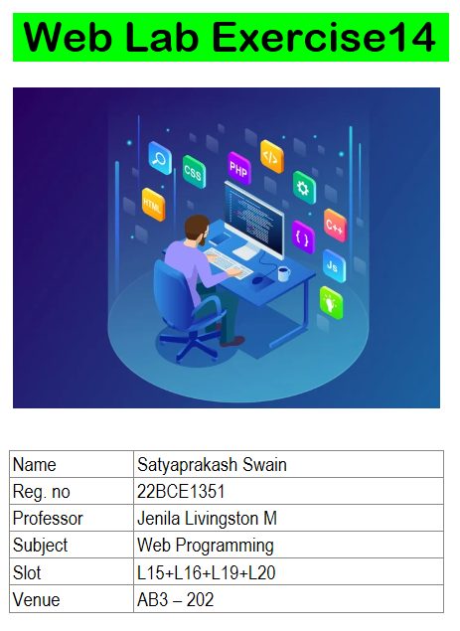

**1. Develop a React component to display:**

**a) An image from the public/Images folder**

**b) An image from the src/Images folder**

import React from 'react';

import srcImage from './Images/Character_3.png';

function ImageDisplay() {

*return* (

<div>

<h2>Image from Public Folder</h2>

<img

src="/Images/Login.png"

alt="Public Folder"

style={{ width: '300px', height: 'auto' }}

/>

<h2>Image from Src Folder</h2>

<img

src={srcImage}

alt="Src Folder"

style={{ width: '300px', height: 'auto' }}

/>

</div>

);

}

export default function App() {

*return* (

<div>

<h1>Image Display Component</h1>

<ImageDisplay />

</div>

);

}

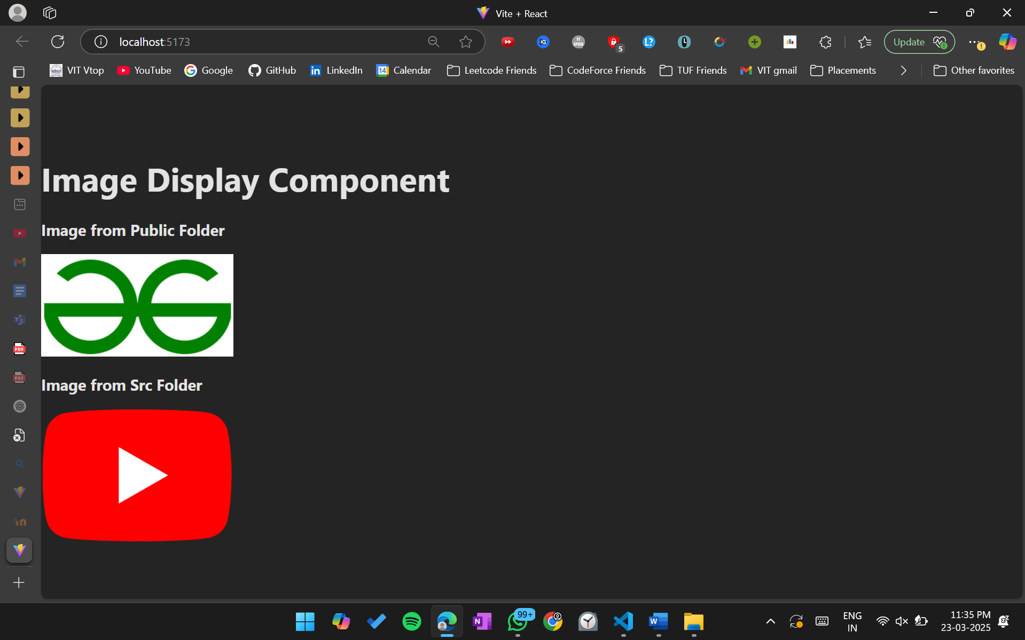

**2. Build a React component to design the following form.**

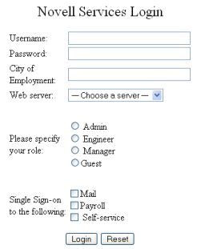

import React, { useState } from 'react';

function LoginForm() {

*const* [formData, setFormData] = useState({

username: '',

password: '',

city: '',

webServer: '',

role: '',

singleSignOn: {

mail: false,

payroll: false,

selfService: false,

},

});

*const* handleChange = (e) => {

*const* { name, value, type, checked } = e.target;

if (type === 'checkbox') {

setFormData((prevData) => ({

**...**prevData,

singleSignOn: {

**...**prevData.singleSignOn,

[name]: checked,

},

}));

} else {

setFormData((prevData) => ({ **...**prevData, [name]: value }));

}

};

*const* handleSubmit = (e) => {

e.preventDefault();

console.log('Form Data:', formData);

alert('Login submitted successfully!');

};

*const* handleReset = () => {

setFormData({

username: '',

password: '',

city: '',

webServer: '',

role: '',

singleSignOn: {

mail: false,

payroll: false,

selfService: false,

},

});

};

*return* (

<div>

<h2>Novell Services Login</h2>

<form onSubmit={handleSubmit}>

<label htmlFor="username">Username:</label>

<input

type="text"

id="username"

name="username"

value={formData.username}

onChange={handleChange}

required

/>

<br />

<br />

<label htmlFor="password">Password:</label>

<input

type="password"

id="password"

name="password"

value={formData.password}

onChange={handleChange}

required

/>

<br />

<br />

<label htmlFor="city">City of Employment:</label>

<input

type="text"

id="city"

name="city"

value={formData.city}

onChange={handleChange}

required

/>

<br />

<br />

<label htmlFor="webServer">Web server:</label>

<select

id="webServer"

name="webServer"

value={formData.webServer}

onChange={handleChange}

required

>

<option value="">-- Choose a server --</option>

<option value="server1">Server 1</option>

<option value="server2">Server 2</option>

<option value="server3">Server 3</option>

</select>

<p>Please specify your role:</p>

<label>

<input

type="radio"

name="role"

value="Admin"

checked={formData.role === 'Admin'}

onChange={handleChange}

/>

Admin

</label>

<br />

<label>

<input

type="radio"

name="role"

value="Engineer"

checked={formData.role === 'Engineer'}

onChange={handleChange}

/>

Engineer

</label>

<br />

<label>

<input

type="radio"

name="role"

value="Manager"

checked={formData.role === 'Manager'}

onChange={handleChange}

/>

Manager

</label>

<br />

<label>

<input

type="radio"

name="role"

value="Guest"

checked={formData.role === 'Guest'}

onChange={handleChange}

/>

Guest

</label>

<p>Single Sign-on to the following:</p>

<label>

<input

type="checkbox"

name="mail"

checked={formData.singleSignOn.mail}

onChange={handleChange}

/>

Mail

</label>

<br />

<label>

<input

type="checkbox"

name="payroll"

checked={formData.singleSignOn.payroll}

onChange={handleChange}

/>

Payroll

</label>

<br />

<label>

<input

type="checkbox"

name="selfService"

checked={formData.singleSignOn.selfService}

onChange={handleChange}

/>

Self-service

</label>

<div style={{ marginTop: '10px' }}>

<button type="submit">Login</button>

<button type="button" onClick={handleReset} style={{ marginLeft: '10px' }}>

Reset

</button>

</div>

</form>

</div>

);

}

export default function App() {

*return* (

<div>

<h1>Novell Services Login Form</h1>

<LoginForm />

</div>

);

}

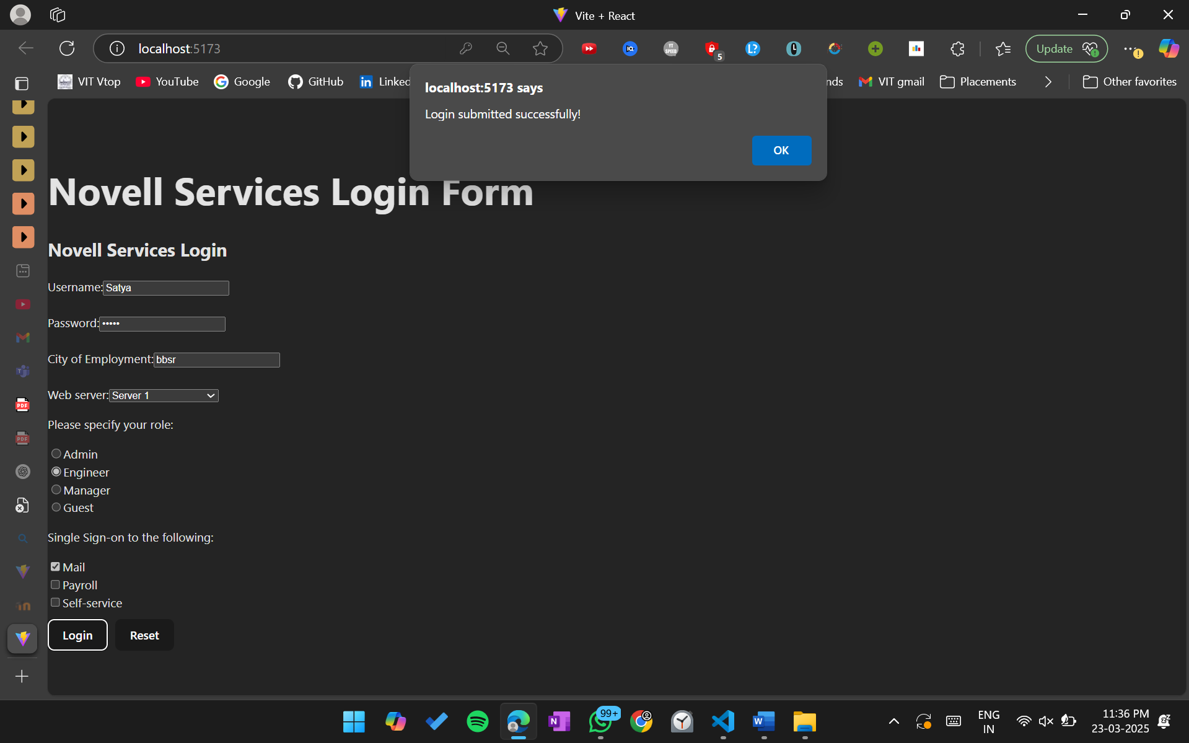

**3. Create a User Profile Page using React with multiple components. The components to**

**Create are as follows:**

**i) ProfileImage.js → Displays the user's profile picture.**

**ii) UserInfo.js → Displays user details (name, email, bio).**

**iii) UserPosts.js → Displays a list of posts by the user.**

**iv) ProfilePage.js → Combines all the above components to form the complete profile page.**

**v) Index.js – Renders the ProfilePage component as the main parent component.**

1. **ProfileImage.js**

import React from 'react';

*const* ProfileImage = ({ imageUrl }) => {

*return* (

<div>

<img

src={imageUrl}

alt="User Profile"

style={{ width: '150px', height: '150px', borderRadius: '50%' }}

/>

</div>

);

};

export default ProfileImage;

1. **UserInfo.js**

import React from 'react';

*const* UserInfo = ({ name, email, bio }) => {

*return* (

<div style={{ margin: '20px 0' }}>

<h2>{name}</h2>

<p><strong>Email:</strong> {email}</p>

<p><strong>Bio:</strong> {bio}</p>

</div>

);

};

export default UserInfo;

1. **UserPosts.js**

import React from 'react';

*const* UserPosts = ({ posts }) => {

*return* (

<div>

<h3>User Posts</h3>

<ul>

{posts.map((post, index) => (

<li key={index}>

<strong>{post.title}</strong>: {post.content}

</li>

))}

</ul>

</div>

);

};

export default UserPosts;

1. **ProfilePage.js**

import React from 'react';

import ProfileImage from './ProfileImage';

import UserInfo from './UserInfo';

import UserPosts from './UserPosts';

*const* ProfilePage = () => {

*const* user = {

name: 'Saumya Gupta',

email: 'saumya@example.com',

bio: 'A passionate developer who loves building web applications.',

imageUrl: 'https://placehold.co/600x400',

};

*const* posts = [

{ title: 'Post 1', content: 'This is the content of the first post.' },

{ title: 'Post 2', content: 'This is the content of the second post.' },

{ title: 'Post 3', content: 'This is the content of the third post.' },

];

*return* (

<div style={{ padding: '20px', fontFamily: 'Arial, sans-serif' }}>

<h1>User Profile</h1>

<ProfileImage imageUrl={user.imageUrl} />

<UserInfo name={user.name} email={user.email} bio={user.bio} />

<UserPosts posts={posts} />

</div>

);

};

export default ProfilePage;

1. **Index.js**

import React from 'react';

import ReactDOM from 'react-dom';

import ProfilePage from './ProfilePage';

ReactDOM.render(

<React.StrictMode>

<ProfilePage />

</React.StrictMode>,

document.getElementById('root')

);

